**CS 5200 - DATABASE THEORY AND APPLICATIONS**

**A**

**Project**

**On**

**“LIBRARY MANAGEMENT SYSTEMS”**

**Submitted by**

**Sharath Kumar Thungathurthi - 700761116**

**Avulamanada Thriveni -700760050**

**Geya Geethika Chigurupati - 700759784**

**Revanth Gangarapu - 700758227**

**INDEX**

|  |  |  |
| --- | --- | --- |
| **Sr.**  **No.** | **Particulars** | **Page No.** |
| **1.** | **Introduction** | 3 to 4 |
| **2.** | **Objectives** | 5 to 6 |
| **3.** | **Project Category** | 7 to 9 |
| **4.** | **Software and Hardware Requirement Specification** | 10 to  11 |
| **5.** | **Detailed System Analysis**  5.1 Data Flow Diagram  5.2 Numbers of Modules and Process Logic  5.3 Data Structures and Tables  5.4 Entity Relationship Diagram | 12 to  16 |
| **6.** | **System Design**  6.1 Form Design  6.2 Source Code  6.3 Input Screen and Output Screen | 18 to  27 |
| **7.** | **Testing and Validation Checks** | 28 to  31 |
| **8.** | **System Security Measures** | 32 to  33 |
| **9.** | **Implementation, Evaluation and Maintenance** | 34 to  35 |
| **10.** | **Future Scope of Project** | 36 to  37 |
| **11.** | **Conclusion** | 38 to  39 |

# INTRODUCTION

## INTRODUCTION

The "Library Management System" has been developed to override the problems prevailing in the practicing manual system. This software is supported to eliminate and, in some cases, reduce the hardships faced by this existing system. Moreover, this system is designed for the particular need of the company to carry out operations in a smooth and effective manner.

The application is reduced as much as possible to avoid errors while entering the data. It also provides error message while entering invalid data. No formal knowledge is needed for the user to use this system. Thus, by this all it proves it is user-friendly. Library Management System, as described above, can lead to error free, secure, reliable and fast management system. It can assist the user to concentrate on their other activities rather to concentrate on the record keeping. Thus, it will help organization in better utilization of resources.

Every organization, whether big or small, has challenges to overcome and managing the information of Books, Student, Librarian, Address, Member. Every Library Management System has different Student needs; therefore, we design exclusive employee management systems that are adapted to your managerial requirements. This is designed to assist in strategic planning, and will help you ensure that your organization is equipped with the right level of information and details for your future goals. Also, for those busy executive who are always on the go, our systems come with remote access features, which will allow you to manage your workforce anytime, at all times.

The applications include:

* Login Form
* Admin Page
* Student Information
* Book Information
* Issuing Books
* Borrowing Books

These systems will ultimately allow you to better manage resources.

# OBJECTIVE

### OBJECTIVES

The main objective of the Project on Library Management System is to manage the details of Student, Books, Issues, Librarian, Member. It manages all the information about Student, Address of Member as well as Student. The project is totally built at administrative end and thus only the administrator is guaranteed the access. The purpose of the project is to build a web-based application program to reduce the manual work for managing the Student, Books, Address, Issues. It tracks all the details about the Issues, Librarian, Member, etc.

1. The objectives of a library management system is to operate a library with efficiency and at reduced costs. The system being entirely automated streamlines all the tasks involved in operations of the library.
2. The activities of book purchasing, cataloging, indexing, circulation recording and stock checking are done by the software. Such software eliminates the need for repetitive manual work and minimizes the chances of errors.
3. The library management system software helps in reducing operational costs. Managing a library manually is labor intensive and an immense amount of paperwork is involved. An automated system reduces the need for manpower and stationery. This leads to lower operational costs.
4. The system saves time for both the user and the librarian. With just a click the user can search for the books available in the library. The librarian can answer queries with ease regarding the availability of books.
5. Adding, removing or editing the database is a simple process. Adding new members or cancelling existing memberships can be done with ease.
6. Stock checking and verification of books in the library can be done within a few hours. The automated system saves a considerable amount of time as opposed to the manual system.
7. The library management system software makes the library a smart one by organizing the books systematically by author, title and subject. This enables users to search for books quickly and effortlessly.
8. Students need access to authentic information. An advanced organized library is an integral part of any educational institution.
9. In this digital age a web-based library management system would be ideal for students who can access the library’s database on their smartphones.
10. The main objective of the Project of Library Management System is to manage the details of users as well as books.
11. It also manages all the information about Student, Address of Member as well as Student

**PROJECT CATEGORY**

### Project Category

A category of project is web-based application named “Library Management System”. Login Form and Main Window are designed by using Python language with Tkinter module. MySQL are used for the database connection with python.

**Programming Language and Database Connectivity Used In Project: Python:-**

Python is an interpreted, object-oriented, high-level programming language with dynamic semantics. Its high-level built in data structures, combined with dynamic typing and dynamic binding, make it very attractive for Rapid Application Development, as well as for use as a scripting or glue language to connect existing components together. Python's simple, easy to learn syntax emphasizes readability and therefore reduces the cost of program maintenance. Python supports modules and packages, which encourages program modularity and code reuse. The Python interpreter and the extensive standard library are available in source or binary form without charge for all major platforms, and can be freely distributed.

The Python installers for the Windows platform usually include the entire standard library and often also include many additional components. For Unix-like operating systems Python is normally provided as a collection of packages, so it may be necessary to use the packaging tools provided with the operating system to obtain some or all of the optional components.

Guido van Rossum began working on Python in the late 1980s as a successor to the ABC programming language and first released it in 1991 as Python 0.9.0. Python 2.0 was released in 2000 and introduced new features such as list comprehension, cycle- detecting garbage collection, reference counting, and Unicode support. Python 3.0, released in 2008, was a major revision that is not completely backward-compatible with earlier versions. Python 2 was discontinued with version 2.7.18 in 2020. Python consistently ranks as one of the most popular programming languages.

### Oracle SQL

Oracle SQL is a Relational Database Management System (RDBMS) developed by Oracle that is based on Structured Query Language (SQL). SQL is one of the most recognizable technologies in the modern big data ecosystem. Often called the most popular database and currently enjoying widespread, effective use regardless of industry, it’s clear that anyone involved with enterprise data or general IT should at least aim for a basic familiarity of SQL. With SQL, even those new to relational systems can immediately build fast, powerful, and secure data storage systems. SQL’s programmatic syntax and interfaces are also perfect gateways into the wide world of other popular query languages and structured data stores.

A database is a structured collection of data. It may be anything from a simple shopping list to a picture gallery or a place to hold the vast amounts of information in a corporate network. In particular, a relational database is a digital store collecting data and organizing it according to the relational model. In this model, tables consist of rows and columns, and relationships between data elements all follow a strict logical structure. An RDBMS is simply the set of software tools used to actually implement, manage, and query such a database.

SQL is integral to many of the most popular software stacks for building and maintaining everything from customer-facing web applications to powerful, data- driven B2B services. Its open-source nature, stability, and rich feature set, paired with ongoing development and support from Oracle, have meant that internet-critical organizations such as Facebook, Twitter, Wikipedia, and YouTube all employ

SQL backends.

# SOFTWARE AND HARDWARE REQUIREMENT SPECIFICATIONS

## Hardware

Hardware is a term that refers to all the physical parts that make up a computer. The internal hardware devices that make up the computer. Various devices which are essentials to form a hardware is called as components.

Following are the hardware specifications that is required to develop this project is as follows:

* 1. Computer components like Monitor, Keyboard, Mouse, CPU, Keyboard.
  2. Minimum 1 GB ram for smooth working of application.
  3. 250 GB Hard Disk or More. CD ROM Drive.

## Software

Computer software, or simply software, is a collection of data or computer instructions that tell the computer how to work. This is in contrast to physical hardware, from which the system is build and actually performs the work.

* **Front End-** Python, CSS, HTML.5.
* **Back End-** OracleMySQL Workbench
* **Text Editors-** VS Code Editor

## Operating System

#### Windows10

#### Ubuntu Linux

**DETAILED SYSTEM ANALYSIS**

## Data Flow Diagram

**LIBRARY MANAGEMENT SYSTEM**

**DATABASE**

**Number of Modules And Process Logic**

### Modules used in Project:

from tkinter import* import tkinter

from tkinter import ttk

from PIL import Image,ImageTk from tkinter import messagebox import random

import time import datetime

import mysql.connector from time import strftime

## Data Structures and Tables

1. **Registration:**

This is a Oracle Database in which the Administrator can manage the User Registration details.

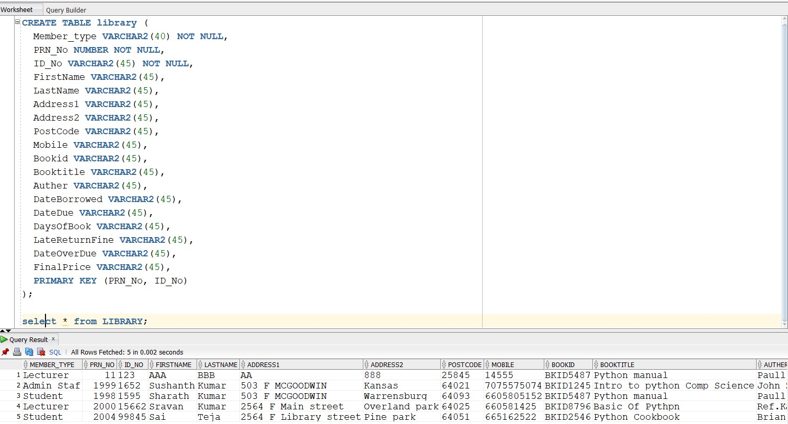

## User Details:

This is a Oracle Database in which the Administrator can manage the User details of Library Management System.

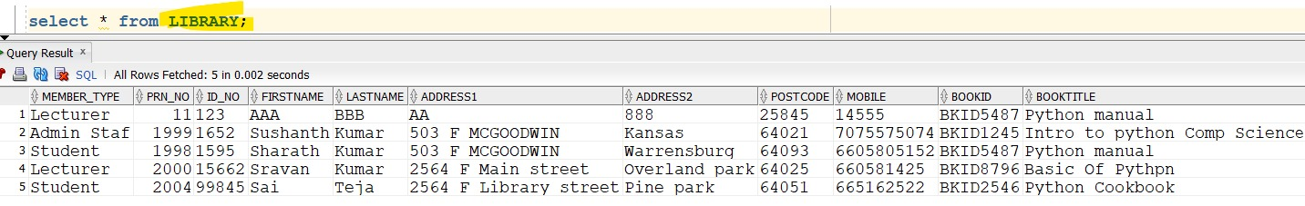

**Entity Relationship Diagram**

#PRN_No

**BOOKS**

**BOOKS**

#Author_Name

#Book_Name

#Book_Code

**Issues**

#Book_ID

**ISSUES**

#Return_Date

#Date_Over_Due

#Member_ID

#Late_Return_Fine

#Issue_Date

**MEMBER**

**MEMBER**

Member_Type

First_Name

Mobile Last_Name

Member_ID

# SYSTEM DESIGN

## Form Design

1. **Admin:**

This is the Library Management System Login Form. You have to enter Username and Password on it. There are also options like New User Registration and Forget Password.

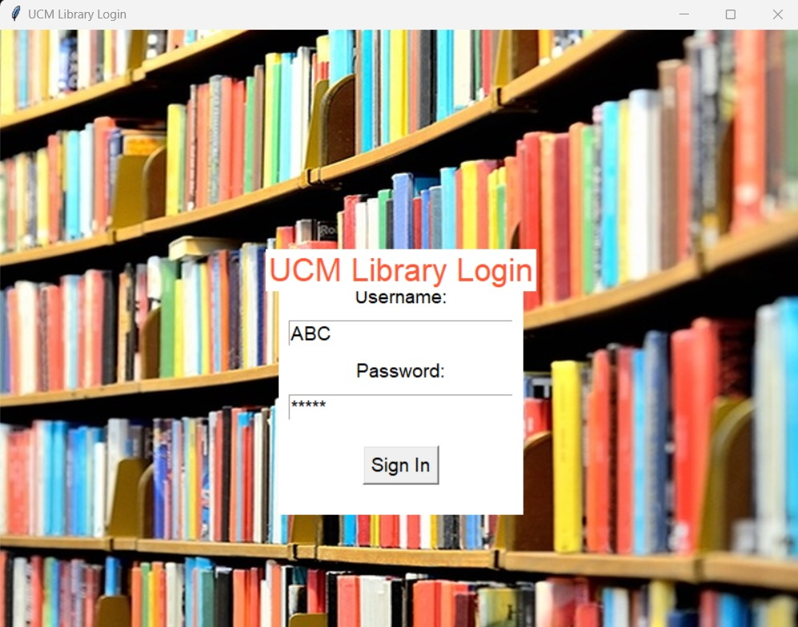

## Home:

## This is the Main Window of the Library Management System. From here admin uses this system.

## 

## User Details:

This is the Library Management System User Details Form. This form shows the user details such as

First name, Last Name, Contact, Addresses and other details to the Administrator.

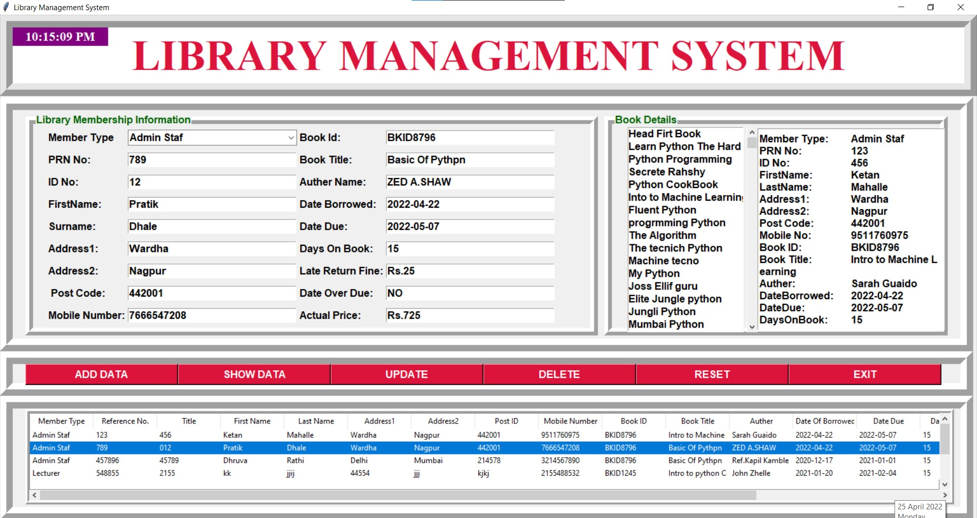

## Book Details:

This is Library Management System Book Details Form. This form shows the details of the Books of the Library such as the Title of the Book, Author Name, Price of the Book and other details to the Administrator.

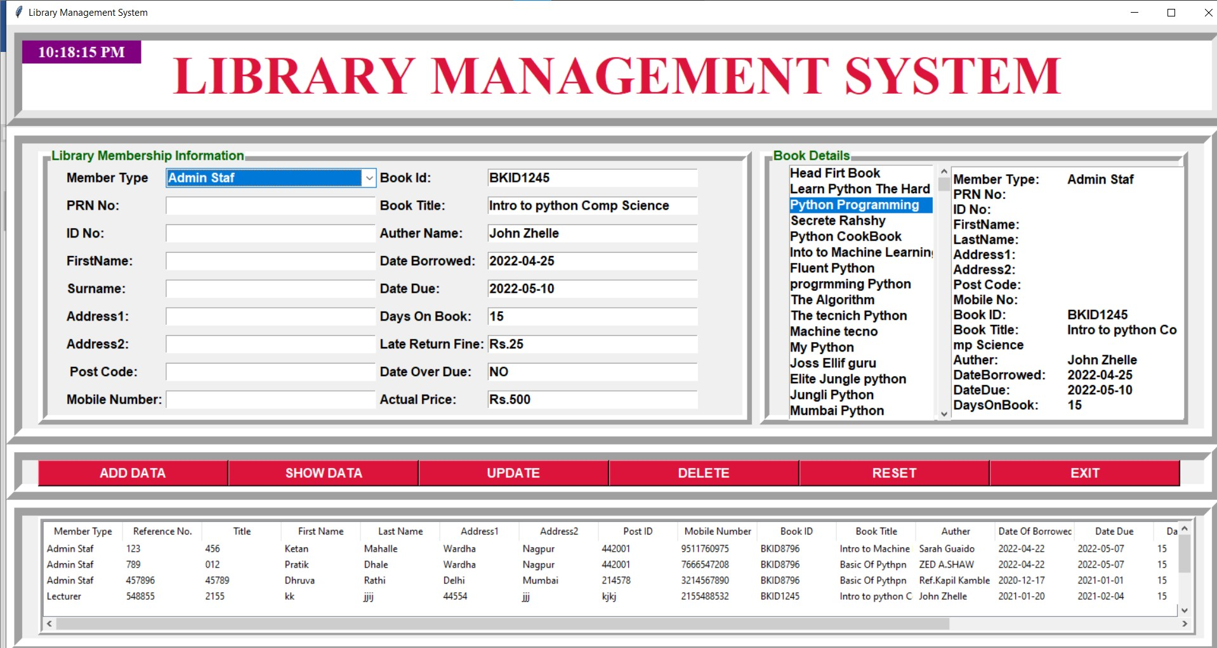

## Input Screen and Output Screen

## Login Page:

## Input: This is the Library Management System login form. Here the Admin has to enter his Username and Password. When the Admin registers, the email he enters is his Username.

## 

## Output: After the admin has entered his username and password, the admin has to click on the ‘login’ button. The library management system screen will open only if the admin has entered the correct username and password, otherwise not. ‘enter in library management system’ application asks user to enter or not.

## 

## Add Data:

1. 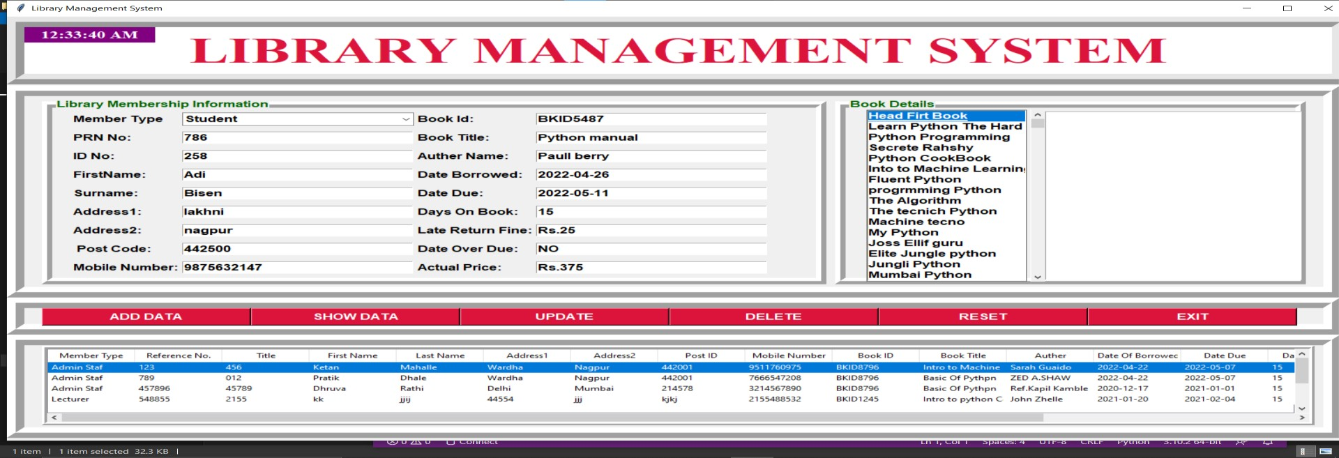**Input**: Admin can add data of members and Books in Library Management System. To add new or old member's data., the admin has to enter the Member's First Name, Last Name, Contact, PRN No and other details. The admin has to click on the book that the member wants to issue and next click on the ‘ADD DATA’button.
2. **Output:**

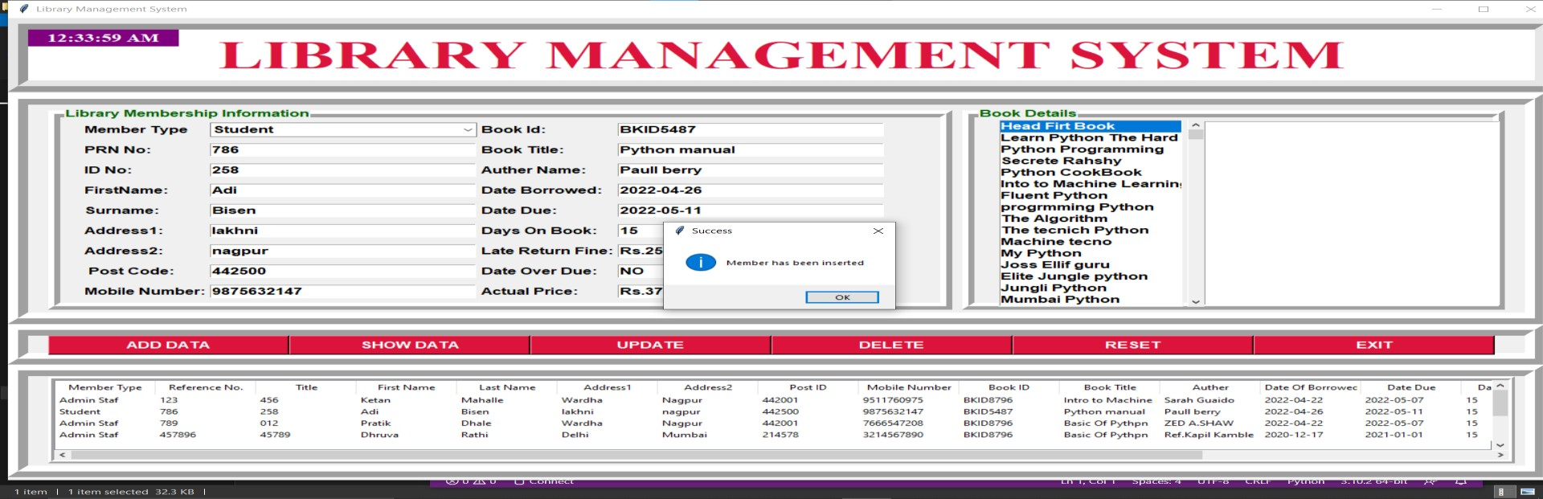When the admin clicks on the ‘ADD DATA’ button, Admin will see the message 'Member has been Inserted' on the screen.

## Update Data:

1. **Input:** When the Admin needs to update the details of any member, Admin has to select member from the scroll bar and after selecting member, Admin can change any detail of member. After changing, click on the ‘UPDATE’ button.

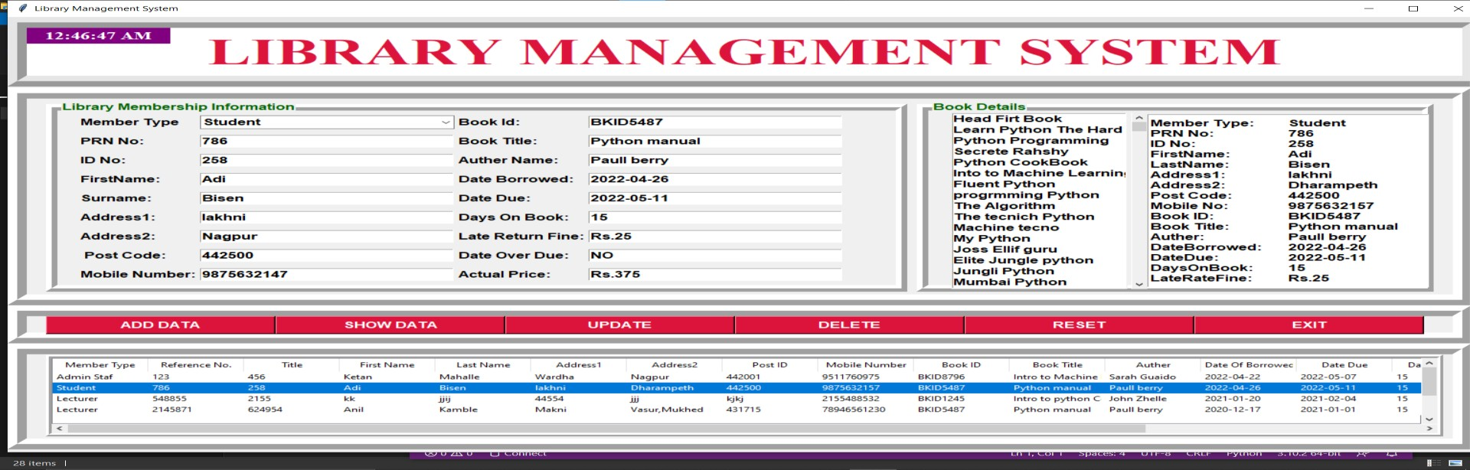

1. **Output:** When the Admin clicks on the ‘UPDATE’ button, Admin will see a 'Record has been Updated Successfully' message on the screen.

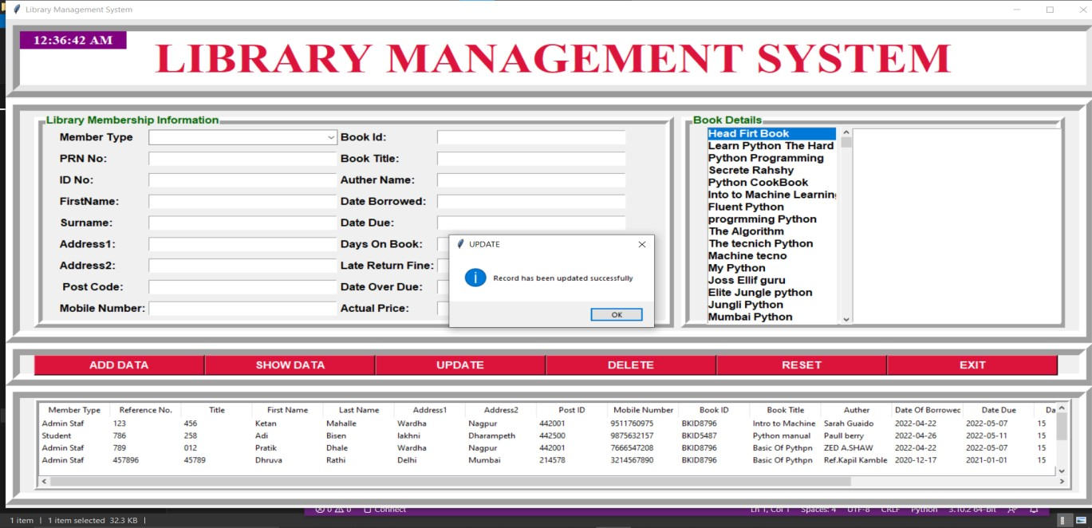

## Delete Data:

## Input: When an Administrator wants to delete a member, the Administrator has to select that member from the scroll bar and click on the ‘DELETE’ button.

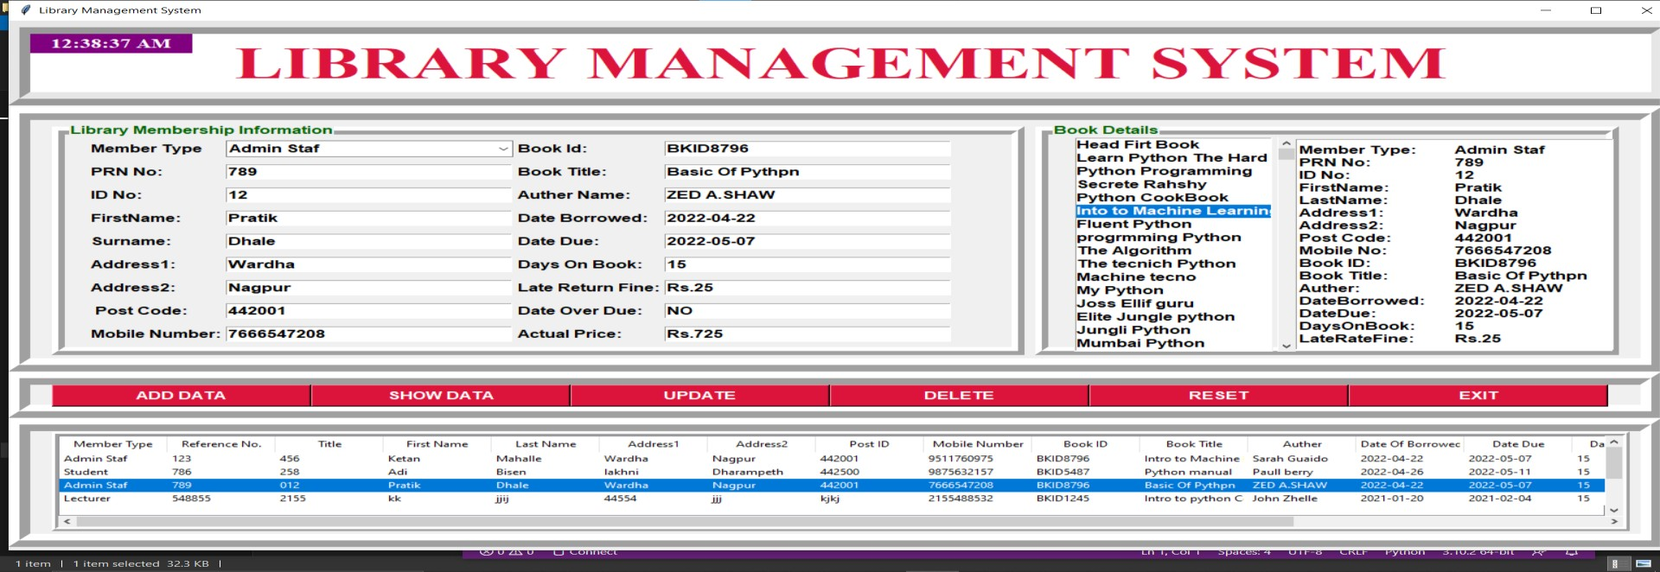

1. **Output:** When the Admin clicks on the ‘DELETE’ button, Admin will see a 'Member has been Deleted Successfully' message on the screen.

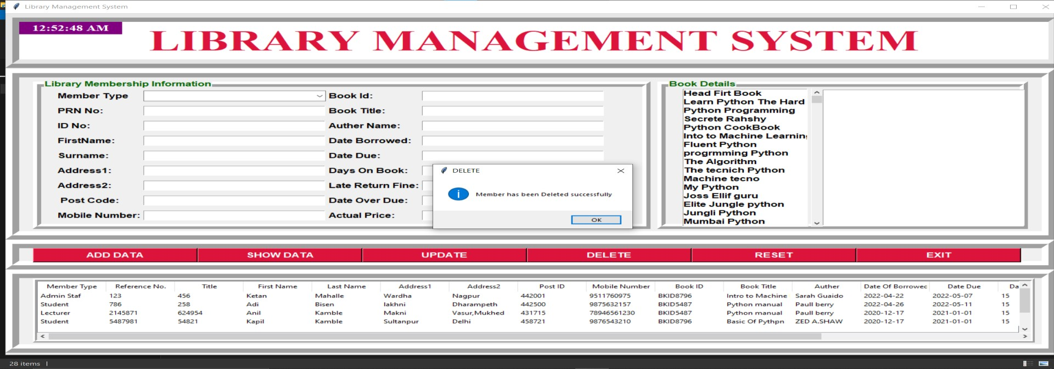

## Reset Data:

1. **Input:** Admin will click on ‘RESET’ button when Admin has to clear the Library Management System screen.

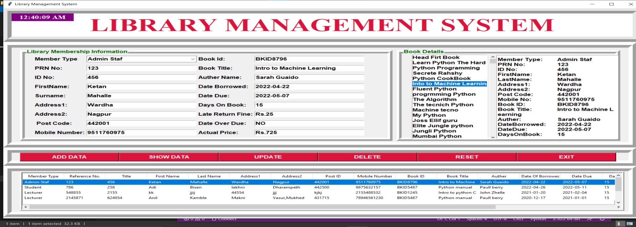

## Output: When the admin will click on the ‘RESET’ button, the Library Management System screen will be completely cleared and it will look like it has just been opened.

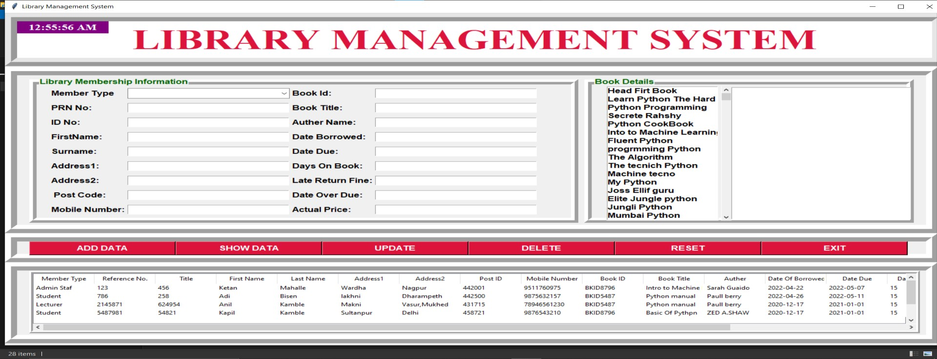

## Exit:

When the Administrator's task is over and Admin wants to close the Library Management System, Admin has to click on the ‘EXIT’ button. When Admin clicks on the ‘EXIT’ button Admin will see the message box. It will ask ‘Confirm if you want to Exit’. If Admin clicked 'Yes' button the screen will closed and if Admin clicked 'No' button the screen will stay on.

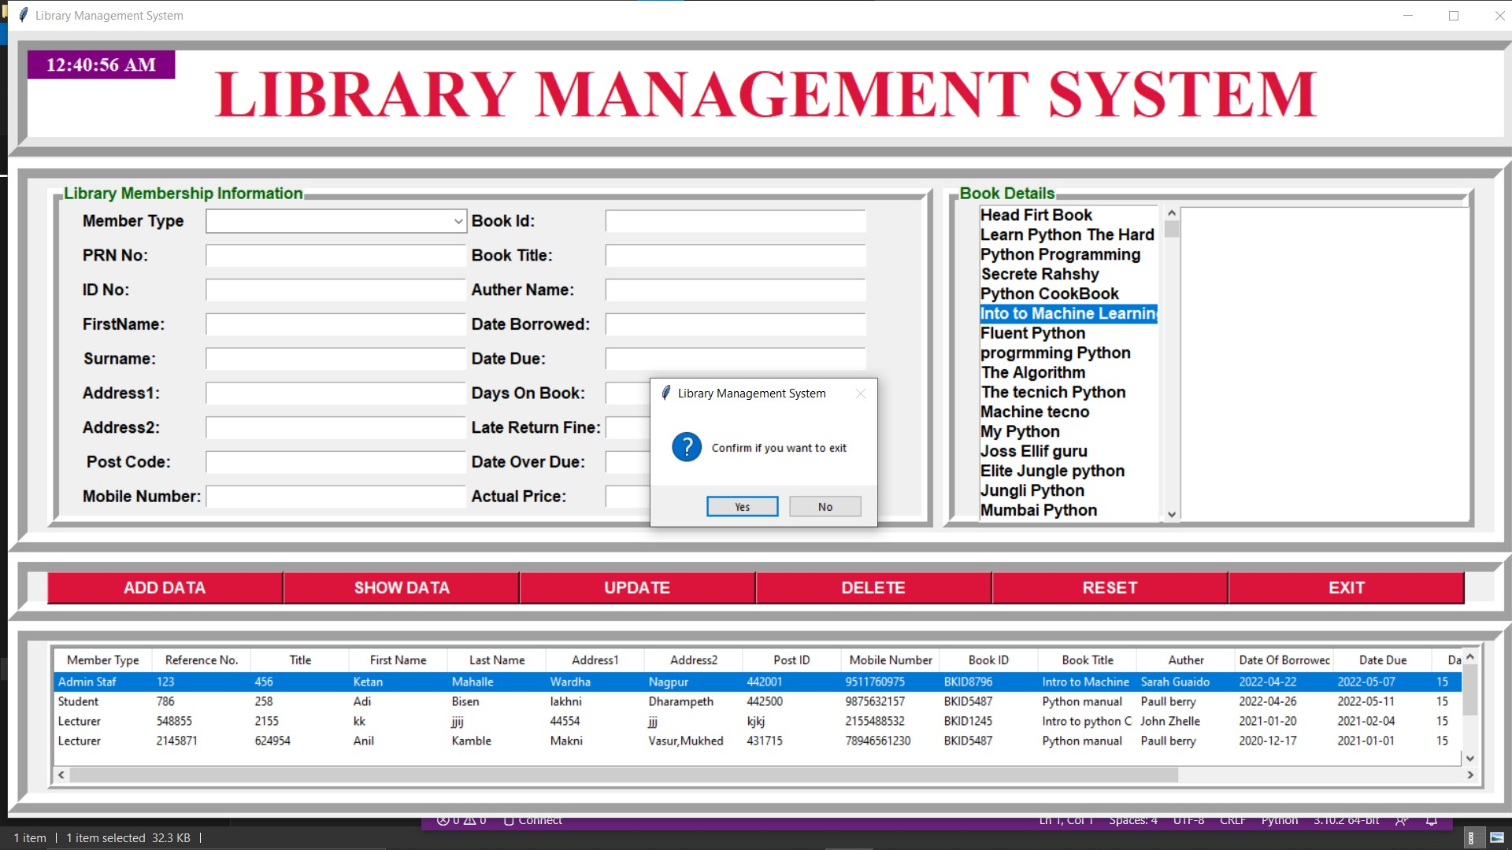

**TESTING AND VALIDATION CHECKS**

### Testing

System testing of software or hardware is testing conducted on a complete, integrated system to evaluate the system's compliance with its specified requirements. System testing falls within the scope of black-box testing, and as such, should require no knowledge of the inner design of the code or logic. As a rule, system testing takes, as its input, all of the "integrated" software components that have passed integration testing and also the software system itself integrated with any applicable hardware system(s). The purpose of integration testing is to detect any inconsistencies between the software units that are integrated together (called assemblages) or between any of the assemblages and the hardware. System testing is a more limited type of testing; it seeks to detect defects both within the "inter-assemblages" and also within the system as a whole. Our Project went through two levels of testing:

* Unit Testing
* Integration Testing

**UNIT TESTING:**

Unit testing is undertaken when a module has been created and successfully reviewed. In order to test a single module, we need to provide a complete environment i.e., besides the module we would require:

* The procedures belonging to other modules that the module under test calls.
* Non local data structures that module accesses.
* A procedure to call the functions of the module under test with appropriate parameters.

#### Test For the admin module:

#### Testing admin login form-This form is used for log in of administrator of the system. In this we enter the username and password if both are correct administration page will open otherwise if any of data is wrong it will get redirected back to the login page and again ask for username and password.

#### Student account addition- In this section the admin can verify student details from student academic info and then only add student details to main library database it contains add and delete buttons if user click add button data will be added to student database and if he clicks delete button the student data will be deleted.

#### Book Addition- Admin can enter details of book and can add the details to the main book table also he can view the books requests.

#### Test for Student login module:

#### Test for Student login Form- This form is used for log in of Student. In this we enter the library id, username and password if all these are correct student login page will open otherwise if any of data is

#### wrong it will get redirected back to the login page and again ask for library id, username and password.

**Test for account creation-** This form is used for new account creation when student does not fill the form completely it asks again to fill the whole form when he fill the form fully it gets redirected to page which show waiting for conformation message as his data will be only added by administrator after verification.

#### Test for teacher login module:

**Test for teacher login form-** This form is used for log in of teacher .In this we enter the username and password if all these are correct teacher login page will open otherwise, if any of data is wrong it will get redirected back to the login page and again ask for username and password.

**INTEGRATION TESTING:**

### In this type of testing, we test various integration of the project module by providing the input. The primary objective is to test the module interfaces in order to ensure that no errors are occurring when one module invokes the other module.

### Validation Checks

The process of evaluating web-based application during the development process or at the end of the development process to determine whether it satisfied information requirement. Validation testing ensures that the product actually meets the user needs. It can also have defined as to demonstrate that the information fulfills its intended use when deployed on appropriate environment.

Validation testing can be best demonstrated. The web-based application under test is evaluated during this type of testing.

* + **VALIDATION INPUT TRANSACTION: -**

Validation input data is largely done through website which is the programmer’s responsibility but it is important that system analyst must know what a common problem might in validation a transaction. Business committed to quality will include validation checks a part of their routine website.

1. Submitting the wrong data to system.
2. Submitting the data by an unauthorized person.
3. Asking the system to perform an unacceptable function.
   * **VALIDATION INPUT DATA: -**

It is essential that the input data themselves along with the transaction requested are valid. Several texts can be incorporated into website to ensure the validity. We consider many possible ways to validate input and they are as follows:

1. Test for missing data.
2. Test for correct field length.
3. Test for range or reasonable.
4. Test for comparison with stored data.

### SYSTEM SECURITY MEASURES

## System security measures

Security of a computer system is a crucial task. It is a process of ensuring confidentiality A system is said to be secure if its resources are used and accessed as intended under all the circumstances, but no system can guarantee absolute security from several of the various threats and unauthorized access.

Security measures will be taken:

* Strong passwords:

This first measure is taken that users may use special characters in their passwords and password get

strong.

* Confidentiality:

If any users are sharing their personal details in login form it will be secure safely as only users can access such information.

* Hidden Password:

Whenever user input the password in login form, then password show in * (Asterisk) format.

**IMPLEMENTATION EVALUATION AND MAINTAINANCE**

## Implementation

The design of a management information system may seem to management to be an expensive project, the cost of getting the MIS on line satisfactorily may often be comparable to that of its design, and the implementation has been accomplished when the outputs of the MIS are continuously utilized by decision makers. Once the design has been completed, there are four basic methods for implementing the MIS.

These are following:

* 1. **Install the system in a new operation or organization.**
  2. **Cut off the old system and install the new:**

This produces a time gap during which no system is in operation. Practically, installation requires one or two days for small companies or small systems.

#### Cut over by segments:

This method is also referred as” phasing in” the new system. Small parts or subsystems are substituted for the old. In the case of upgrading old systems, this may be a very desirable method.

#### Operate in parallel and cut over:

The new system is installed and operated in parallel with the current system until it has been checked out, then only the current system is cut out. This method is expensive

because of personal and related costs. Its big advantages are that the system is fairly well debugged when it becomes the essential information system.

## Evolution

After the MIS has been operating smoothly for a short period of time, an evaluation of each step in the design and of the final system performance should be made. Evaluation should not be delayed beyond the time when the system’s analysts have completed most of the debugging. The longer the delay, the more difficult it will be for designer to remember important details. The evaluation should be made by the customer as well as by the designers.

## Maintenance

Control and maintenance of the system are the responsibilities of the line managers. Control of the systems means the operation of the system as it was designed to operate. Sometimes, well-intentioned people or operators may make unauthorized changes to improve the system, changes that are not approved or documented. Maintenance is closely related to control. Maintenance is that ongoing activity that keeps the MIS at the highest levels of effectiveness and efficiency within cost constraints. Maintenance is directed towards reducing errors due to design, reducing errors due to environmental changes and improving the system’s scope and services.

# FUTURE SCOPE OF PROJECT

## FUTURE SCOPE OF PROJECT

Our web-based application “Library Management System” which provides complete information about Users like Student, Admin and Lecturer. We will add more content on them in future. In our web-based application right now, only Books and Users with their information available but in future we will add Online Lectures, Links, etc.

We will also provide more images in GUI related to our web-based application in future. We will try to find out more about this topic and add in future. We will try to make this application more attractive so that visitor cannot get bored while using it. We will provide login id to each and every user so that he can access our website from anywhere through log in id and password. In future we add some major facilities like Reservation of Book.

We will also provide more images in GUI related to our web-based application in future. We will try to find out more about this topic and add in future. We will try to make this application more attractive so that visitor cannot get bored while using it. We will provide login id to each and every user so that he can access our website from anywhere through log in id and password. In future we add some major facilities like Reservation of Book.

# CONCLUSION

**CONCLUSION**

Library Management System allows the user to store the book details and the customer details. This software package allows storing the details of all the data related to library. The system is strong enough to withstand regressive yearly operations under conditions where the database is maintained and cleared over a certain time

of span. The implementation of the system in the organization will considerably reduce data entry, time and

also provide readily calculated reports.